http://dbmc2023.civil.tsinghua.edu.cn

XVI DBMC – Presentation

The triennial conferences of DBMC (Durability of Building Materials and Components) have been recognized as a high-quality forum for scientific research and knowledge sharing in the broad areas of civil engineering and architecture. The past 15 editions of DBMC conferences have brought forth deep insights and technical solutions to the key challenges confronting the whole engineering community. Today, more than ever, the engineering community should be mobilized to address the global issue of sustainability for our whole society.

Tsinghua university proudly announces the XVI DBMC conference from October 10-13, 2023 in Beijing, China. The 4-day event will be hosted by the organizing team from the School of Civil Engineering, Tsinghua university（http://www.civil.tsinghua.edu.cn/en/), together with the sponsoring organizations and institutions. The XVI DBMC will focus on the solutions of building industry to the sustainability development, promoting the multi-disciplinary exchanges and collaborations among material science, data science, and civil and environmental engineering. Consequently, the conference topics will cover innovative materials, durability performance and practice, intelligent construction, and life-cycle engineering. The XVI DBMC conference provides a communication platform for both scholars and engineers, especially young engineers and students.

Through the website you can the most recent updating for the conference organization and activities. Should you be willing to be involved into the XVI event, please sign up on the front page so that you can explore fully the functionalities. We will do our best to make your involvement an unforgettable experience.

Look forward to meeting you in Beijing in 2023 !

Prof. Kefei Li,
Chair of Organizing Committee
Prof. Dongping Fang,
Chair of Scientific Committee
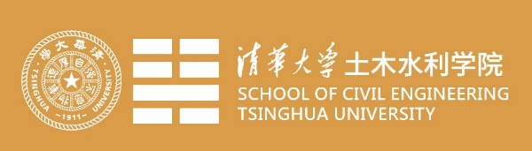

XVI DBMC -Call for paper

The XVI DBMC is committed to the promotion of scientific insight and technological innovation in the fields of civil engineering to help the sustainability of our society. To this purpose, the focus of this conference is put on the sustainability and the related concepts, methods and techniques from civil engineering community.

The main themes of this DBMC edition include, but not limited to, the innovative materials, the conventional durability, the intelligent construction and the life cycle engineering. The innovative materials involve the high performance, eco-green, multi-functional and smart materials. The conventional durability includes the actions and mechanisms, the testing and modeling, the design and assessment, the practice and specifications, and the historical heritage and monuments. The intelligent construction refers to the construction automation and robotics (including 3D printing), and the numerical infrastructure and intelligent design. The life cycle engineering covers the life cycle costing and methods, the recycling of wastes, and the carbon reduction and neutralization. In addition, special talks will be arranged for the ongoing or recent mega-projects in China and abroad.

In this context, we extend our warm invitation to you to join this forum of high-quality dissemination and exchange. The abstract submission is open now until December 31, 2022. Please use our conference website (functional from July 15, 2022) to submit your abstract. We look forwards to your contribution to this marvelous event, and do not hesitate to contact us should you have further queries or suggestions to the organization. Your words will be more than welcome.

XVI DBMC -Important Dates

First call for paper July 15, 2022
Abstract submission December 31, 2022
Abstract acceptance January 31, 2023
Full paper submission March 31, 2023
Full paper acceptance May 31, 2023
Early-bird registration January 1, 2023 to June 30, 2023
Regular registration July 1, 2023

XVI DBMC -Contact

Civil Engineering School,
Tsinghua University,
Beijing 100084, China
http://dbmc2023.civil.tsinghua.edu.cn
E-mail: dbmc2023@tsinghua.edu.cn

