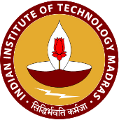
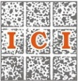

An International Symposium on
“Recent Advances in Concrete Construction and Preservation”
3rd K. P. Pradeep Symposium on Pioneering Science and Development for Construction

Tuesday, December 18, 2018 | Venue TBA

ABOUT THE WORKSHOP
Concrete is the most used man-made material in the world. Current consumption of concrete is more than 30 billion tons per year. Many concrete structures are experiencing premature deterioration and not able to meet the design life. Almost 50% of the concrete structures today experience a repair within about 10 years. It has become necessary to focus on sustainability and durability of concrete in order to address the environmental challenges associated with portland cement manufacturing and enhance the life span of civil infrastructure. If we do not take adequate measures now, then the future generation will face an expensive challenge of repairing the large number of structures. This workshop is aimed to expose engineers and researchers to the state-of-the-art technological advancements in the area of concrete. Among the covered topics are: nanotechnology in construction, service life modeling, sustainability, and 3-D printing of concrete. Lectures will have a blend of underlying scientific principles and practice-oriented viewpoints.

SPEAKERS
- Surendra P. Shah, Northwestern University, USA / IIT Madras, India
- Mark Alexander, University of Cape Town, South Africa
- Venkatesh Kodur, Michigan State University, USA
- Liberato Ferrara, Politecnico di Milano, Italy
- Raul L. Zerbino, Univ. Nacional de La Plata, Argentina
- Manu Santhanam, IIT Madras, Chennai, India
- Ravindra Gettu, IIT Madras, Chennai, India
- Radhakrishna G. Pillai, IIT Madras, Chennai, India
- Nigel Narayan, The Masterbuilder, Chennai, India
- Anoop Devasia, L&T, India

REGISTRATION FEE
- Research Scholars – Rs. 1000 + GST
- Practicing Engineers – Rs. 2500 + GST
COORDINATORS
Dr. Piyush Chaunsali and Prof. Ravindra Gettu
Department of Civil Engineering, Indian Institute of Technology Madras, Chennai, India
Email: pchaunsali@iitm.ac.in; iitmconcrete@gmail.com

PROGRAMME SCHEDULE
Session Timing | Topic | Speaker
8:30 – 9:30 AM | Registration
9.30 – 10:15 AM | Inaugural talk | Prof. Surendra P. Shah  Northwestern University, USA and  IIT Madras, India
10:15 – 11:00 AM | TBD | Prof. Mark Alexander
11:00 – 11:30 AM | Tea/Coffee Break
11:30 – 12:15 PM | 3 D Printing | Prof. Manu Santhanam
12:15 – 1:00 PM | TBD | Prof. Ravindra Gettu
1:00 – 2:00 PM | Lunch Break
2:00 – 2:10 PM | Quality Control of Steel Reinforcement | Dr. Radhakrishna G. Pillai
2:10 – 2:20 PM | Augmented Reality (?) | Nigel, Masterbuilder
2:20 – 2:30 PM | The Statue of Unity (?) | Anoop, L&T
2:30 – 3:00 PM | Tea/Coffee Break
3:00 – 3:45 PM | TBD | Prof. Liberato Ferrara
3:45 – 4:30 PM
4:30 – 5:15 PM | TBD | Prof. Venkatesh Kodur
5:15 – 5:30 PM | Concluding remarks | Prof. Ravindra Gettu  IIT Madras, India
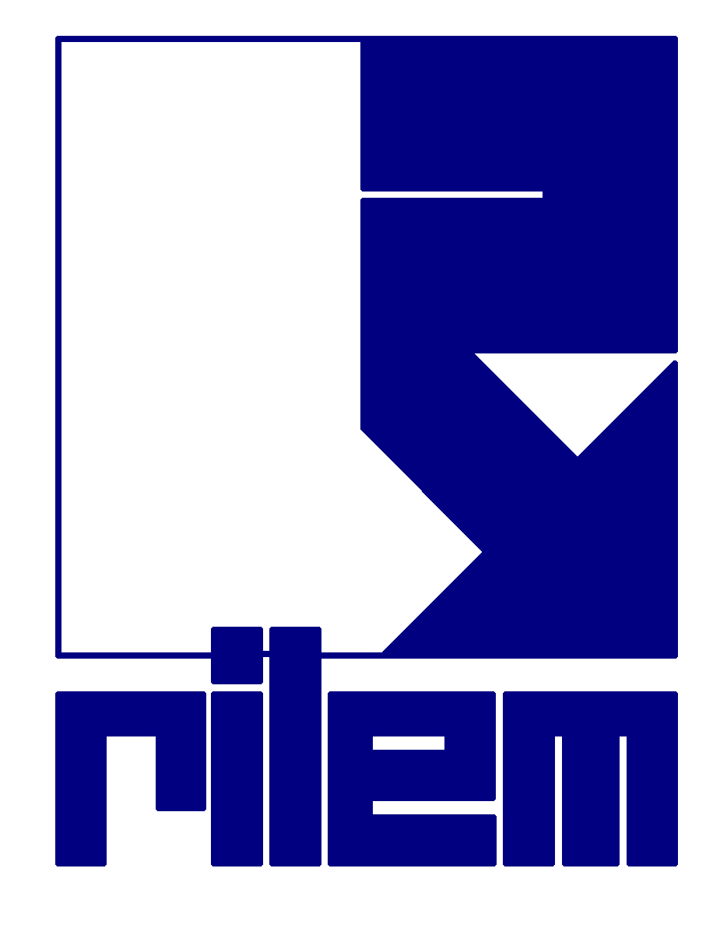

An International Symposium on
“Recent Advances in Concrete Construction and Preservation”
(K. P. Pradeep Symposium on Pioneering Science and Development for Construction)

Tuesday, December 18, 2018 | Venue

