Digital Fabrication with Concrete
In the last years, digital fabrication with cement-based materials has raised a major interest in the architecture and construction industry. The research activities in this field have increased exponentially and various sophisticated solutions for concrete 3D printing are being developed worldwide. On behalf of DAfStb and DBV, we are pleased to invite you to an international workshop on digital fabrication with concrete. The workshop is organised in collaboration with the RILEM Technical Committee “Digital Fabrication of Cementitious Materials” and brings together civil engineers, material scientists and top researchers from academia and industry to present their latest work in this emerging field. Ten speakers from six countries will present the current technical developments and latest case studies from across Europe, and discuss the opportunities and challenges for the practical applications of these promising technologies.

30th of January 2020, 10:00 AM – 05:30 PM
Golden Tulip Berlin – Hotel Hamburg, Landgrafenstraße 4, 10787 Berlin
(welcome coffee from 09:30 AM)
The workshop language is English.

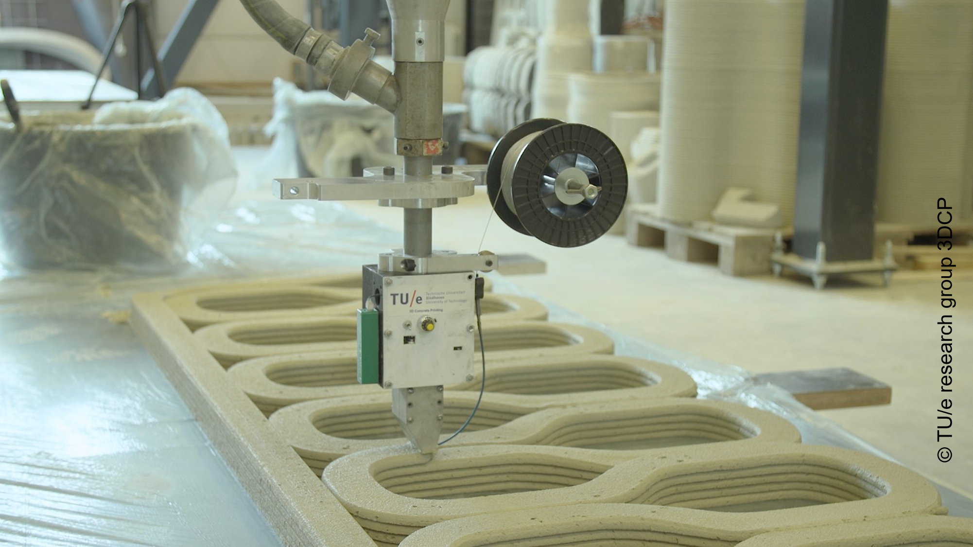

Detailed information:
https://www.betonverein.de/Veranstaltungen/Digital_Fabrication_with_Concrete_2020.pdf

Registration:
https://www.betonverein.de/veranstaltung_anmelden.php?id=702

Registration fee:
179 € for RILEM, DBV or DAfStb members, 229 € for non-members

PROGRAMME
Moderation: Dr.-Ing. Lars Meyer, DBV, Berlin
Welcome and opening
Dr.-Ing. Matthias Jacob, Chair of DBV Board, Implenia Hochbau GmbH, Germany
Digital Fabrication with Concrete – Introduction and Overview
Dr.-Ing. Ksenija Vasilic, DBV, Germany
Particle-bed 3D Printing in Concrete Construction – Possibilities and Challenges
Prof. Dr.-Ing. Dirk Lowke, Technische Universität Braunschweig, Germany
Extrusion-based Concrete 3D Printing
Dr. Freek Bos, Eindhoven University of Technology, the Netherlands
Shotcrete 3D Printing (SC3DP) – 3D Printing of Large-scale Concrete Elements
Jun.-Prof. Dr.-Ing. Norman Hack, Technische Universität Braunschweig, Germany
Digital Concrete Research at ETH Zürich
Dr. Timothy Wangler, ETH Zürich, Switzerland
Rheological Requirements for Printable Concretes
Prof. Nicolas Roussel, IFSTTAR, East Paris University, France
Integration of Reinforcement in Concrete 3D Printed Components and Structures
Prof. Dr.-Ing. Viktor Mechtcherine, Technische Universität Dresden, Germany
3D Concrete Printing: Ideas to Reality
Dr. Richard Buswell, Loughborough University, United Kingdom
The New Ways of Future Building – Industrial Usage of 3D Printing with Concrete
Raphael Zöller M. Sc., Firmengruppe Max Bögl, Germany
A Broader Perspective on 3D Construction Printing – a Practitioner’s Point of View
Henrik Lund-Nielsen MBA and Dr. Fabian Meyer-Brötz, COBOD International A/S, Denmark/Germany
Concluding presentation: German Way Forward
Dr.-Ing. Udo Wiens, DAfStb, Germany

